**DEPLOYMENT OF WORDPRESS THROUGH JENKINS**

**What is Jenkins?**

* Jenkins is free & open source software. It is developed by using java language.
* Jenkins is used to automate “Build and Deployment” process.
* Using Jenkins we can implement “Continuous Integration” and “Continuous Deployment”.
* Continuous integration is a development practice where a code should be deployed into servers automatically when any new code is committed.

**Task-1:** Launch a EC2 Instance by giving “8080” port in security group and connect to the instance.

**Task-2:** Install Jenkins in the instance by executing below command:

* sudo yum update –y
* sudo wget -O /etc/yum.repos.d/jenkins.repo \  
  https://pkg.jenkins.io/redhat-stable/jenkins.repo
* sudo rpm --import <https://pkg.jenkins.io/redhat-stable/jenkins.io.key>
* sudo yum upgrade
* sudo amazon-linux-extras install java-openjdk11 -y
* sudo yum install jenkins -y
* sudo systemctl enable Jenkins
* sudo systemctl start Jenkins

**Task-3:** Connect to http://<your_server_public_DNS>:8080 from your browser. You will be able to access Jenkins through its management interface.

**Task-4:** Enter the password found in **/var/lib/jenkins/secrets/initialAdminPassword**.

Use the following command to display this password:

$ sudo cat /var/lib/Jenkins/secrets/InitialAdminPassword

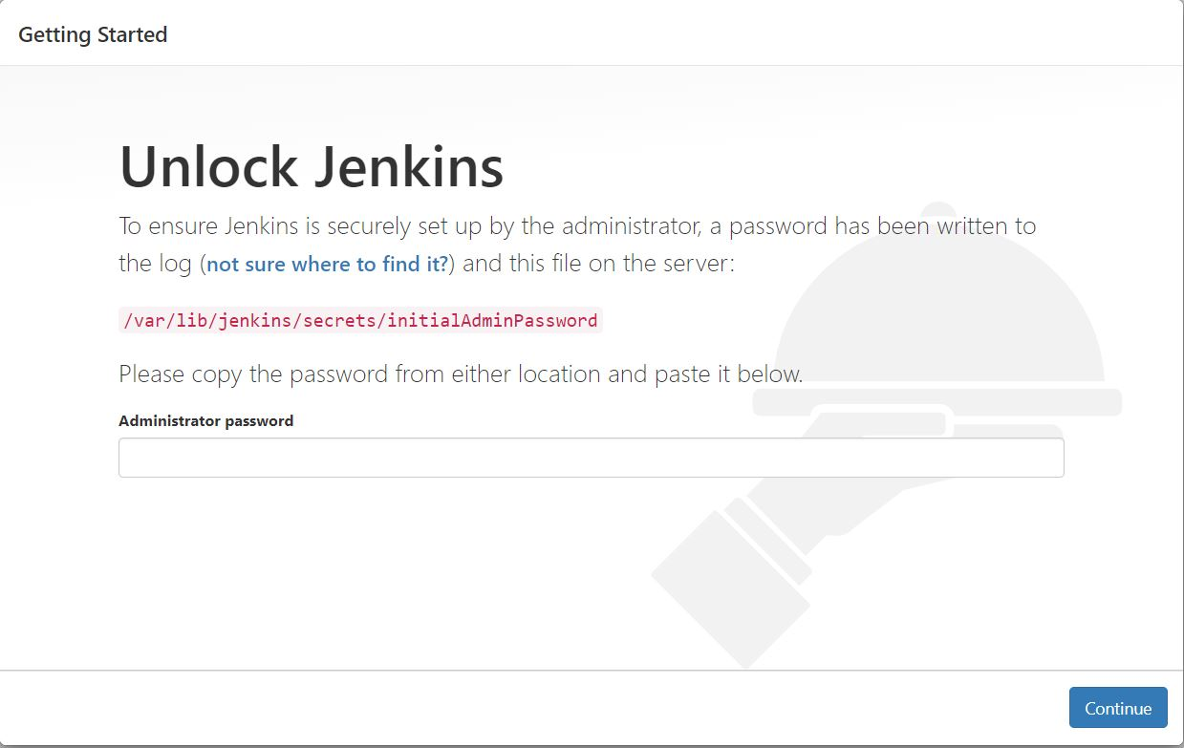

**Task-5:** The Jenkins installation script directs you to the **Customize Jenkins page.** Click **Install suggested plugins.**

* Once the installation is complete, the **Create First Admin User** will open. Enter your information, and then select **Save and Continue.**

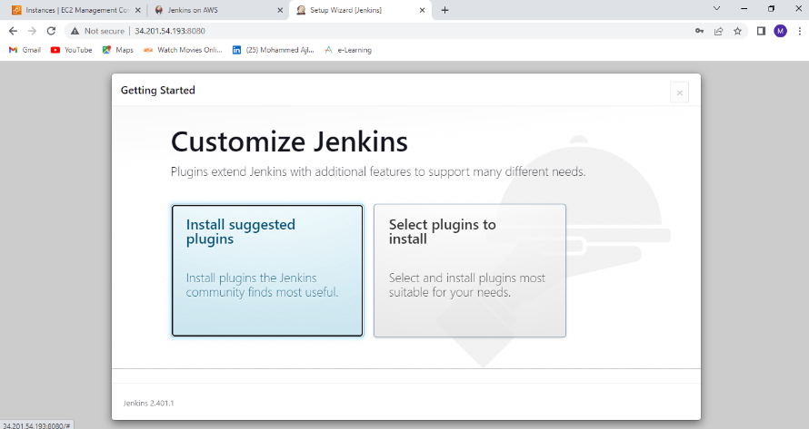

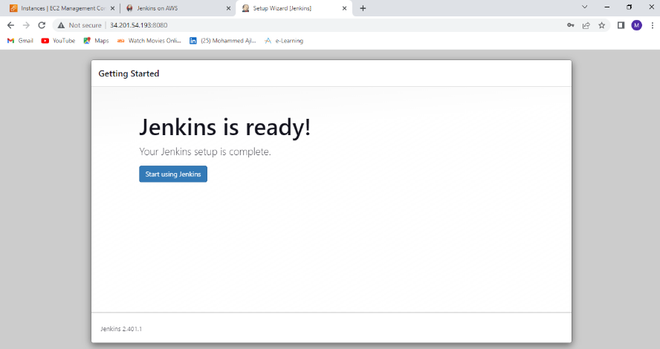

**Task-6:** Once the Jenkins profile setup is completed create a new job by clicking on new item. Select free style project. Give a name to the project(WordPress).

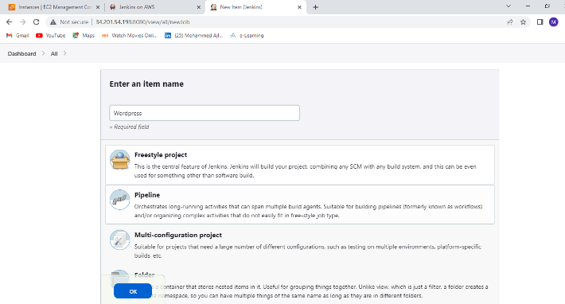

**Task-7:** Give the description of the project.

Under the source code management select Git and provide the repositories details such Repo URL, Credentials like username and password.

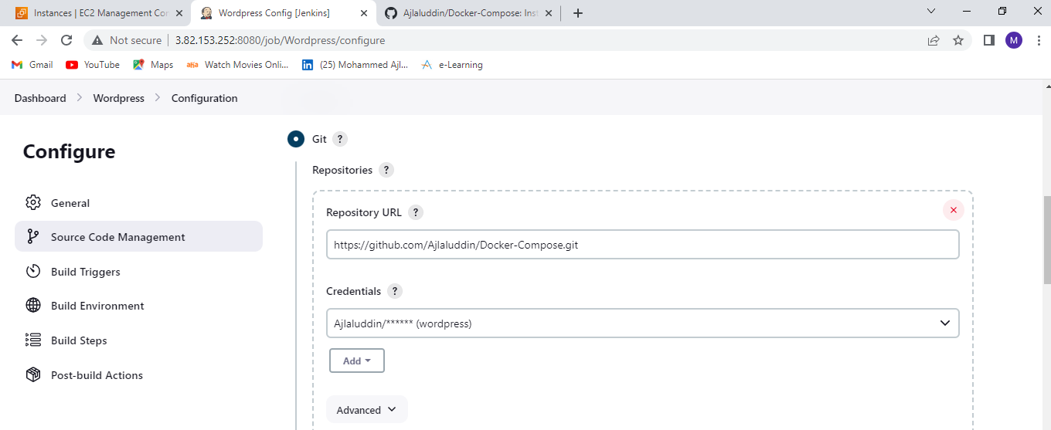

**Task-8:** Under the build section select “Add build step” and click on “Execute Shell” and add the commands which you want to execute during the build process.

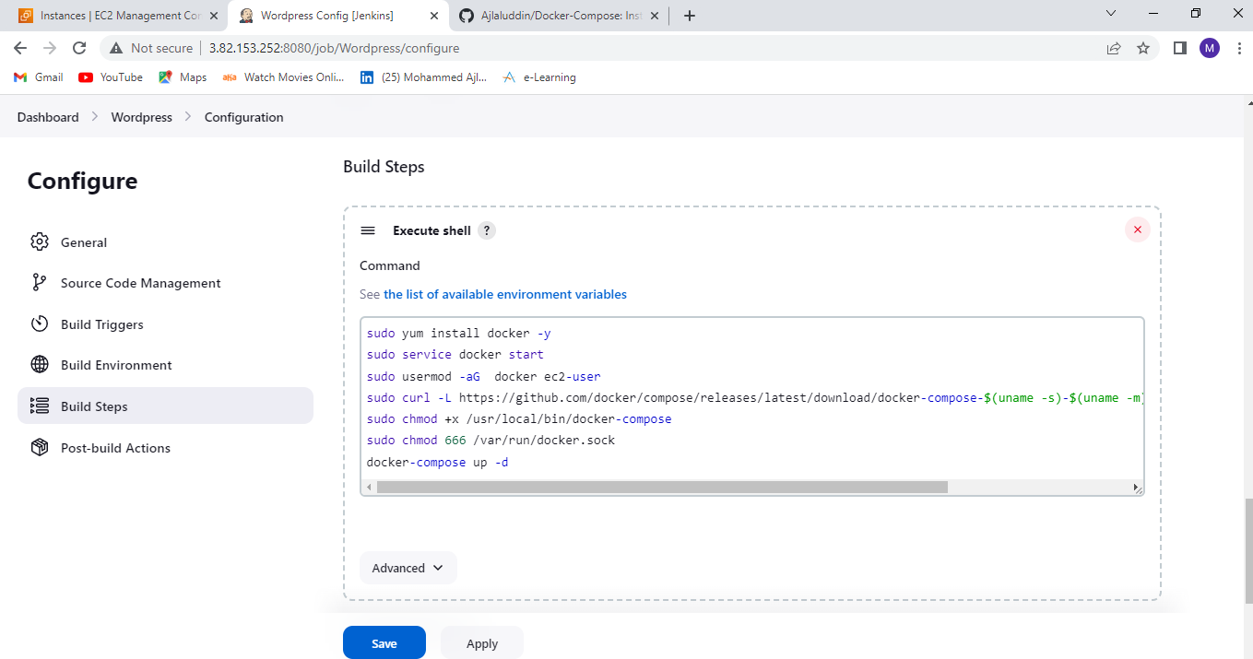

**Commands:**

sudo yum install docker -y to install docker

Sudo service docker start to start the docker service

Sudo usermod -aG docker ec2-user to add user to docker group

sudo curl -L https://github.com/docker/compose/releases/download/1.22.0/docker-compose-$(uname -s)-$(uname -m) -o /usr/local/bin/docker-compose to install docker-compose

sudo chmod +x /usr/local/bin/docker-compose to add permissions

docker-compose up -d to start the containers

**Task-9:** After entering the commands in execute shell click on **“Build now”** to build the

Project. Check the Console output.

**Output:** WordPress and MYSQL container is created. WordPress is deployed.

